Battleship Application: User-Centered Design, Evaluation, and System Integration Study
Kepha Nyanumba Bundi.
La roche University, Pittsburgh, PA.
ISTG6010-01-OBJECT ORIENTED SYSTEMS.
Professor: Dustin Updyke
Spring 2026.

Introduction
This study examines the role of low-fidelity prototyping in uncovering usability challenges during early-stage interface design, using a Battleship application as an exploratory case study. Anchored in the principle that “paper is cheaper than code,” the research investigates how preliminary visualization and user interaction can expose cognitive and structural inefficiencies prior to system implementation.
The analysis is grounded in established human-computer interaction (HCI) frameworks, including cognitive load theory (Sweller, 1988), Nielsen’s usability heuristics (Nielsen, 1994), and Norman’s affordance and mental model theory (Norman, 2013). These frameworks provide a theoretical lens through which design decisions and user behaviors are critically interpreted.
Unlike purely descriptive design reports, this study adopts an evidence-driven, user-centered approach, positioning interface design as an iterative process shaped by empirical observation and theoretical validation.
Design Phase: Wireframe Development
Low-fidelity wireframes were developed to represent the full interaction lifecycle of the Battleship application. The design process emphasized functional clarity, structural consistency, and cognitive efficiency, ensuring that users could construct accurate mental models of system behavior.
The system is decomposed into four primary interfaces:
- Main Menu Interface
- Ship Placement Interface
- Gameplay Interface
- Game Result Interface
Each interface was intentionally simplified to isolate usability factors and enable focused evaluation during the review phase.

Main Menu Interface
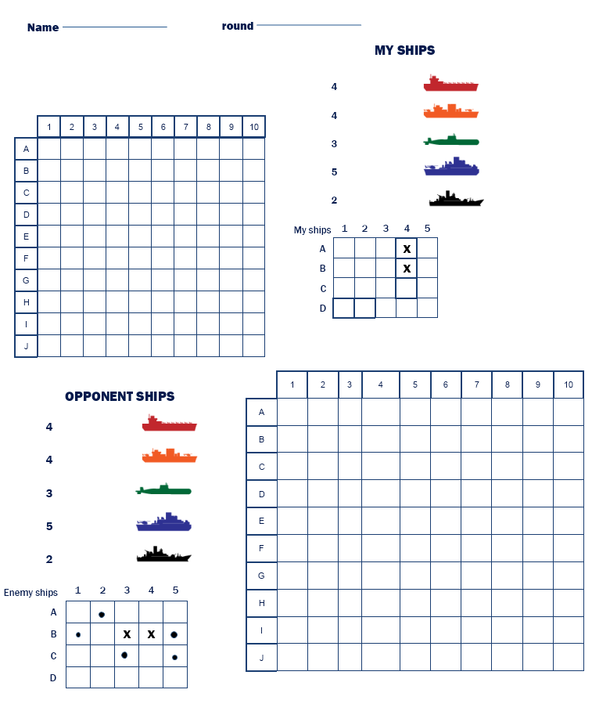
(Figure 1: Main Menu Wireframe)
The main menu establishes the initial interaction context by presenting a hierarchical set of navigation options. The vertical arrangement of controls reflects principles of visual hierarchy and progressive disclosure, enabling users to quickly identify primary actions.
From a cognitive standpoint, the reduction of visual clutter minimizes extraneous cognitive load, allowing users to allocate attention efficiently during initial system engagement.
Ship Placement Interface
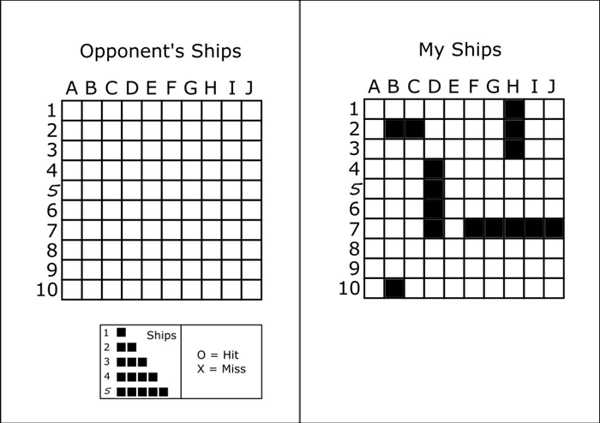
(Figure 2: Ship Placement Wireframe)
The ship placement interface facilitates the configuration of initial game conditions through a structured grid system. The grid inherently conveys placement affordances, enabling intuitive interaction without explicit instruction.
The inclusion of rotational controls enhances interaction flexibility, while maintaining adherence to user control and freedom, a key usability heuristic.
This interface also introduces spatial reasoning demands, making clarity of labeling and orientation critical to usability.
Gameplay Interface
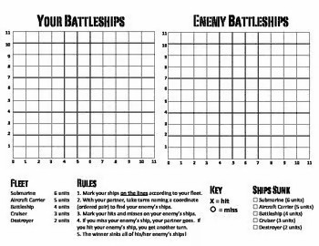
(Figure 3: Gameplay Wireframe)
The gameplay interface constitutes the core interaction environment and is designed using dual-grid architecture, separating offensive and defensive perspectives.
This structural decision is informed by cognitive load theory, as it reduces the need for simultaneous processing of competing information streams. By isolating user tasks, the interface supports more efficient decision-making and reduces error likelihood.
Additionally, the design aligns with users’ existing mental models of Battleship gameplay, reinforcing intuitive interaction.
Game Result Interface
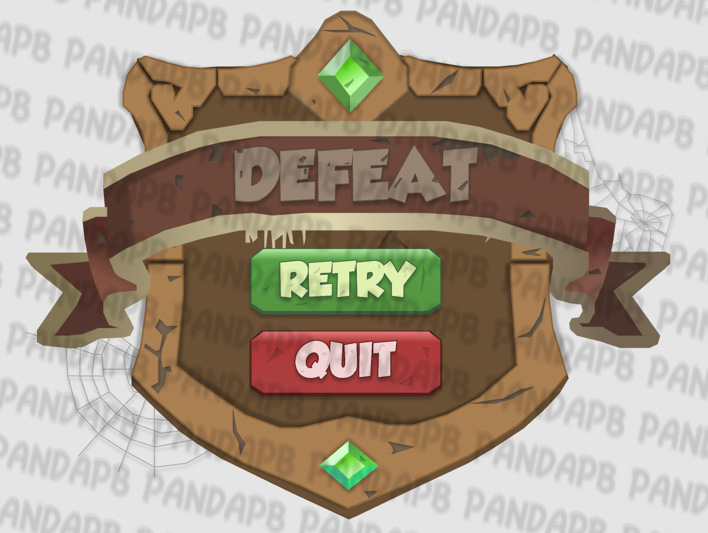
(Figure 4: Result Screen Wireframe)
The result interface provides closure to the interaction cycle by presenting outcome feedback and enabling subsequent actions.
The inclusion of performance metrics supports reflective engagement, while the clear presentation of results aligns with the principle of visibility of system status, ensuring transparency of system outcomes.
Integrated System Design
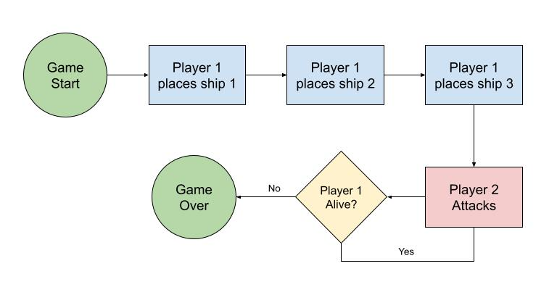
(Figure 5: System Flow Diagram)
While individual interfaces address localized usability, the effectiveness of the application ultimately depends on the coherence of the overall interaction flow.
System Interaction Flow
The application operates as a state-driven system, where user interactions trigger transitions between defined states:
Menu → Setup → Gameplay → Result
Each transition is deterministic and governed by user input, ensuring predictable system behavior.
Finite State Model
The system can be formally represented as a finite state machine (FSM):
- Menu State: Entry and navigation
- Setup State: Configuration of initial conditions
- Gameplay State: Core interaction and logic execution
- Result State: Outcome presentation
This abstraction enables a structured understanding of system behavior and supports scalable implementation.

System Cohesion and Data Continuity
A critical aspect of the design is the preservation of state continuity across transitions. Data generated during ship placement directly informs gameplay logic, while gameplay outcomes determine result state behavior.
This interconnectedness ensures logical consistency, enabling users to form accurate and stable mental models.
Analytical Insight
The integration of interfaces into a unified system reveals that usability is not merely a function of individual components but emerges from the relationships between them. Poorly designed transitions can undermine otherwise effective interfaces, highlighting the importance of flow-oriented design.
Methodology
A structured usability evaluation was conducted with three participants (n = 3), selected to represent both technical and non-technical perspectives.
Task Design
Participants completed three predefined tasks:
- Identify system interaction flow
- Simulate ship placement
- Execute a gameplay action

Data Collection Approach
A think-aloud protocol was employed to capture real-time cognitive processing. Data collected included:
- Task completion time
- Error occurrence
- Verbalized user interpretations
This approach provided both quantitative and qualitative insights into user interaction.
Results
Clarity
All participants successfully identified the overall system flow within approximately 45 seconds, indicating strong macro-level clarity.
However, 2 out of 3 participants misinterpreted coordinate orientation during initial interaction, revealing a critical breakdown in micro-level clarity.
Usability
While all participants completed the assigned tasks, 67% expressed the need for enhanced visual feedback, particularly color-coded indicators.
This indicates insufficient support for real-time system visibility, impacting user confidence and efficiency.

Completeness
Two participants required initial guidance, suggesting that the absence of onboarding increased cognitive demand for first-time users.

Discussion
The findings highlight a fundamental tension between design intuition and user cognition. Elements that appeared self-evident during design were not consistently interpreted by users, underscoring the limitations of assumption-based design.
The observed confusion regarding coordinate orientation reflects a mismatch between system representation and user mental models. This aligns with cognitive load theory, as ambiguous labeling increases processing demands.
Conversely, the effectiveness of the dual-grid system demonstrates the value of aligning interface structure with established user expectations.
These results reinforce the importance of iterative, evidence-driven design, particularly in systems involving spatial interaction and decision-making.
Technical Feasibility and System Architecture
The proposed system can be implemented using a Model-View-Controller (MVC) architecture:
- Model: Manages game state using structured data representations (e.g., 2D arrays)
- View: Renders interface components
- Controller: Processes user input and updates system state

Advanced Considerations
- State synchronization across views
- Event-driven updates for responsiveness
- Modular component design for scalability
This architecture supports maintainability and future expansion.
Security Considerations
While the current design assumes a standalone environment, future networked implementations introduce security risks:
- Client-side manipulation of game state
- Invalid or malicious input
- Unauthorized action execution
Mitigation strategies include:
- Server-side validation
- Controlled state transitions
- Input sanitization

Design Trade-offs
Decision | Alternative | Trade-off
Dual-grid architecture | Single grid | Improved clarity vs increased visual space
Paper prototyping | Digital prototyping | Rapid iteration vs reduced fidelity
Minimalist design | Feature-rich interface | Reduced cognitive load vs reduced guidance
Iterative Improvements
Based on user feedback, the design was refined through:
- Enhanced coordinate labeling
- Introduction of onboarding support
- Standardization of UI components
- Implementation of visual feedback mechanisms
These changes directly address identified usability issues.
Limitations
The study is subject to several limitations:
- Small sample size limits generalizability
- Paper-based prototypes lack interactive realism
- Participant familiarity may introduce bias

Reflection
This study revealed that perceived clarity does not guarantee actual usability. The discrepancy between designer expectations and user interpretation underscores the necessity of empirical validation.
The process reinforced the importance of adopting a user-centered, iterative design approach, where feedback is continuously integrated into system refinement.
Conclusion
This study demonstrates that low-fidelity prototyping is a powerful tool for identifying usability issues in early-stage design. By integrating theoretical frameworks with empirical evaluation, the resulting system design is both cognitively efficient and user informed.
The refined wireframes provide a robust foundation for implementation and highlight the critical role of iterative design in software development.

References
Nielsen, J. (1994). Usability engineering. Morgan Kaufmann.
Norman, D. A. (2013). The design of everyday things (Revised and expanded ed.). Basic Books.
Sweller, J. (1988). Cognitive load during problem solving: Effects on learning. Cognitive Science, 12(2), 257–285.

